Event Ticket Platform – API Documentation
Base URL: /api/v1
Authentication: Bearer JWT
Roles: ROLE_ORGANIZER, ROLE_ATTENDEE, ROLE_STAFF
- Authentication API:
  - Register
Method: POST
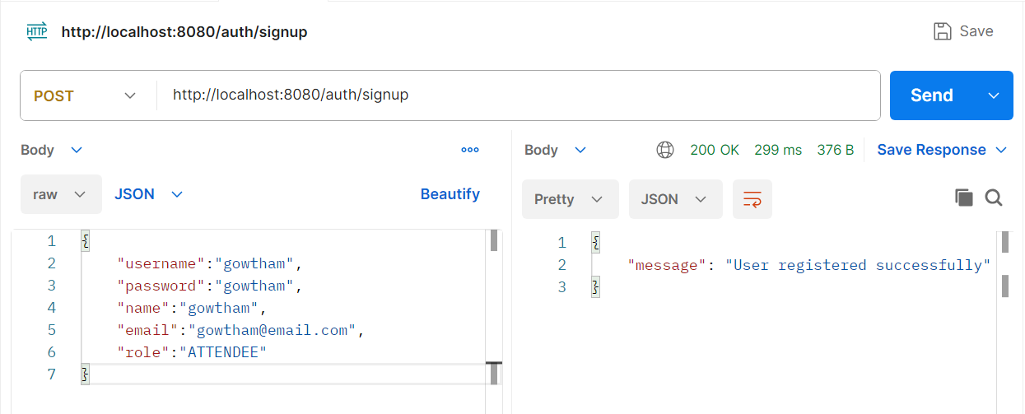

  - Login
Method: POST
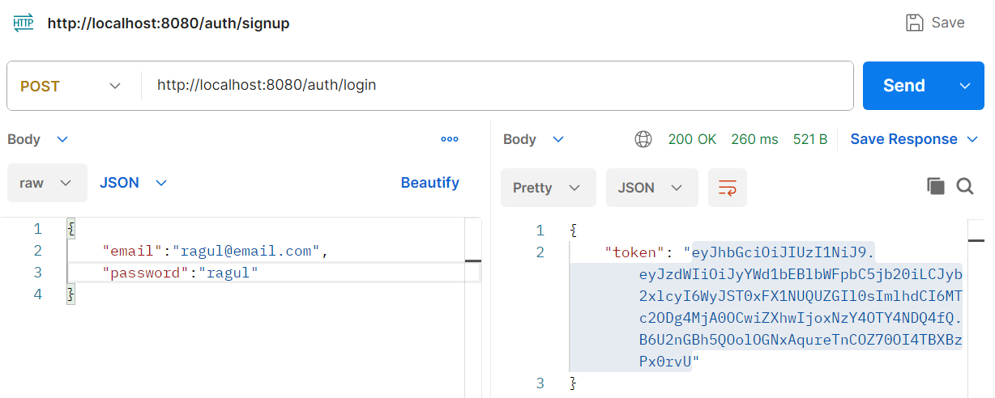

  - Reset Password
Method: POST
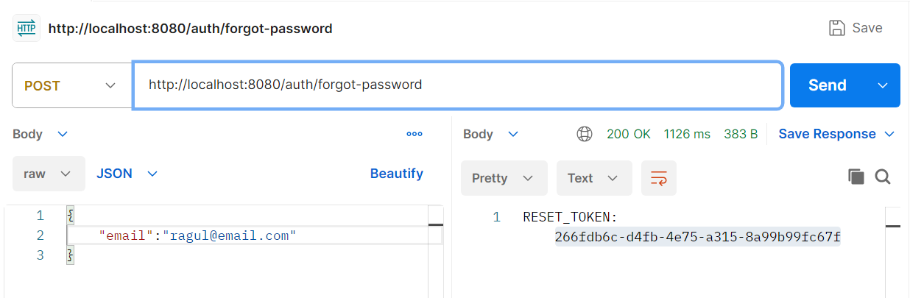

  - Reset Password
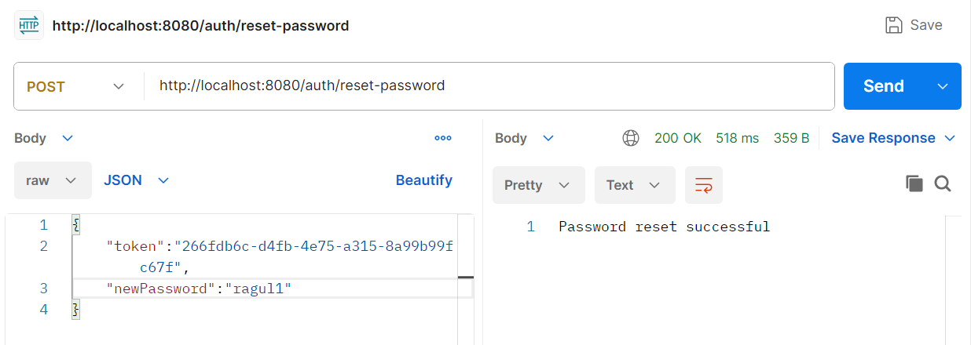

- Events
2.1 Create Event– (ROLE_ORAGANIZER)
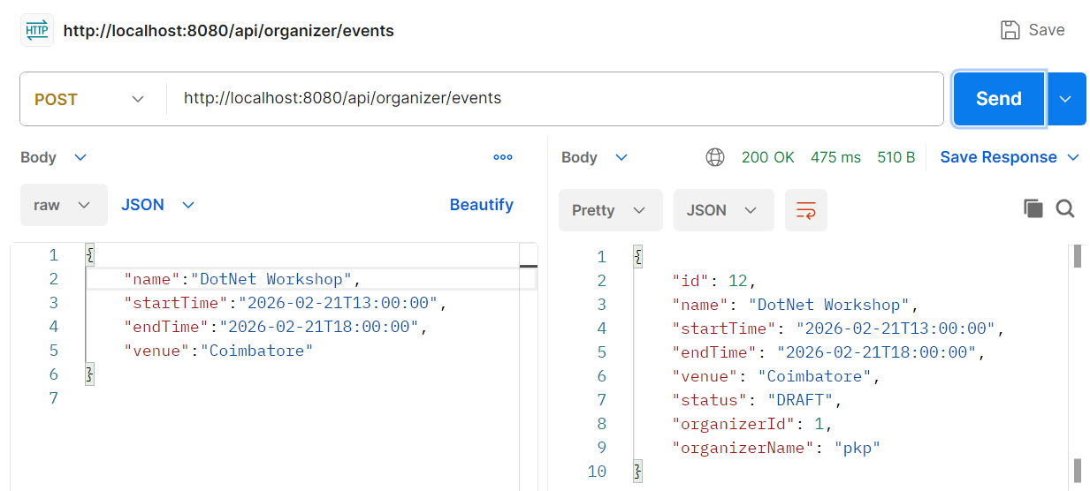

2.2 Get All Events– (ROLE_ORAGANIZER)
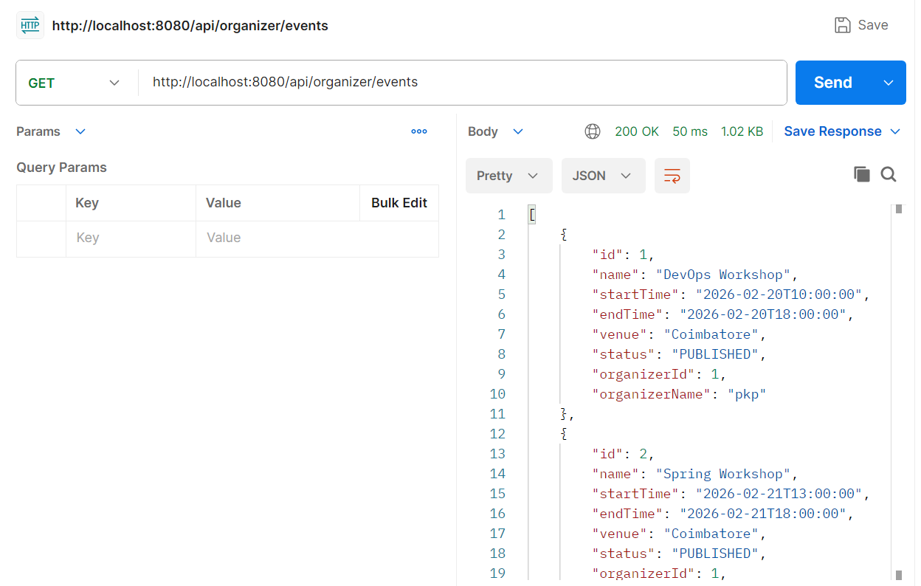

2.3 Publish Events– (ROLE_ORAGANIZER)
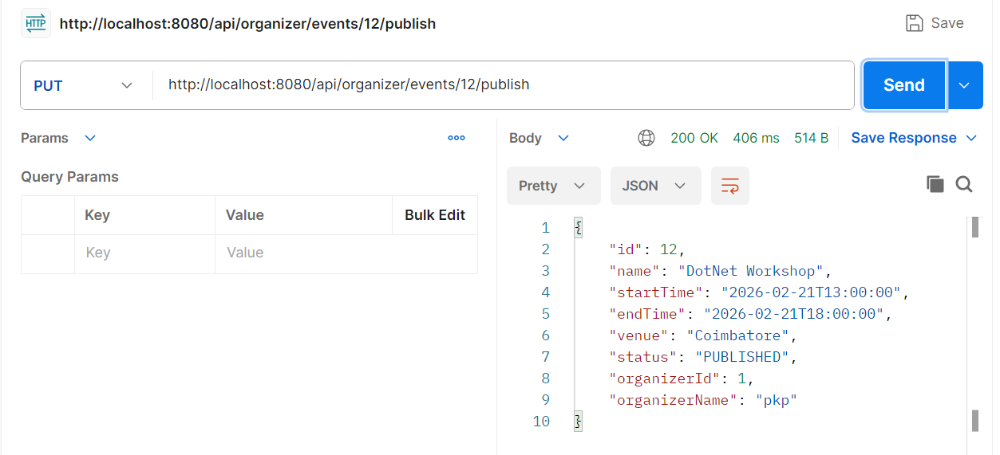

2.4 Cancel Events– (ROLE_ORAGANIZER)
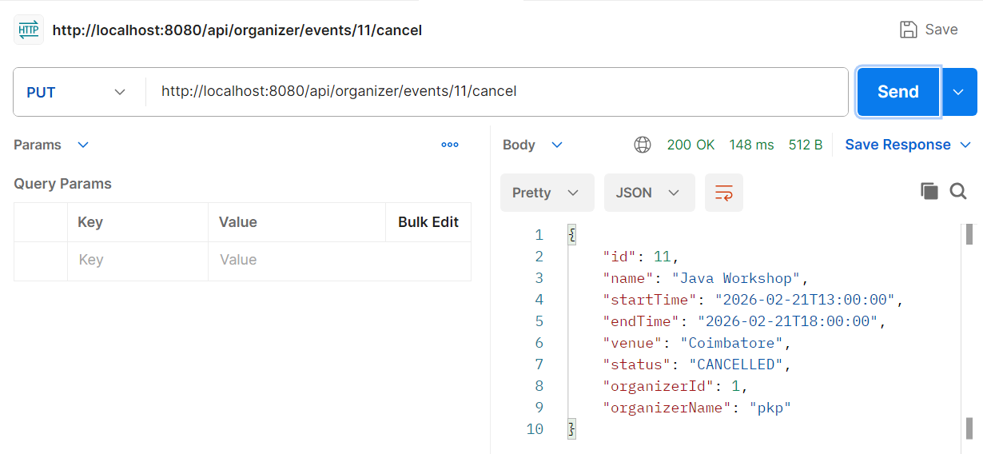

2.5 Assign Staff to a event - (ROLE_ORAGANIZER)
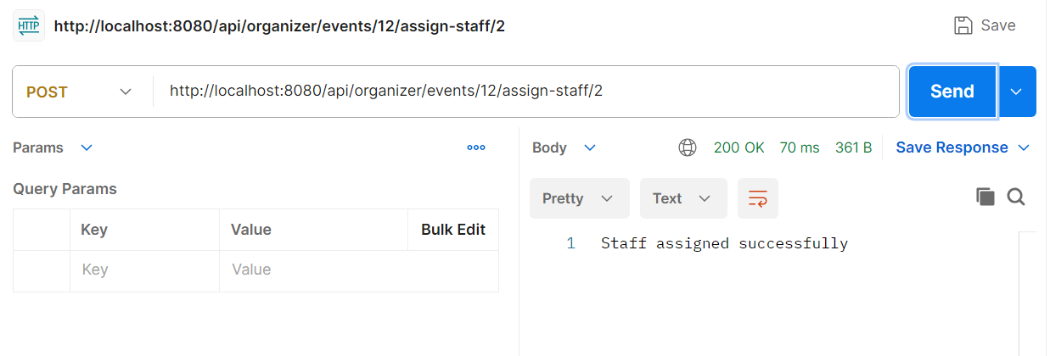

2.6 List of staffs assigned to a event - (ROLE_ORAGANIZER)
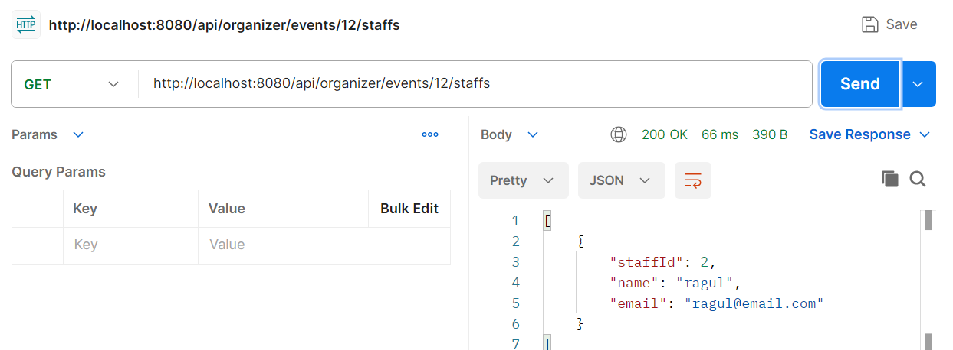

2.7 List all published events- (ROLE_ATTENDEE)

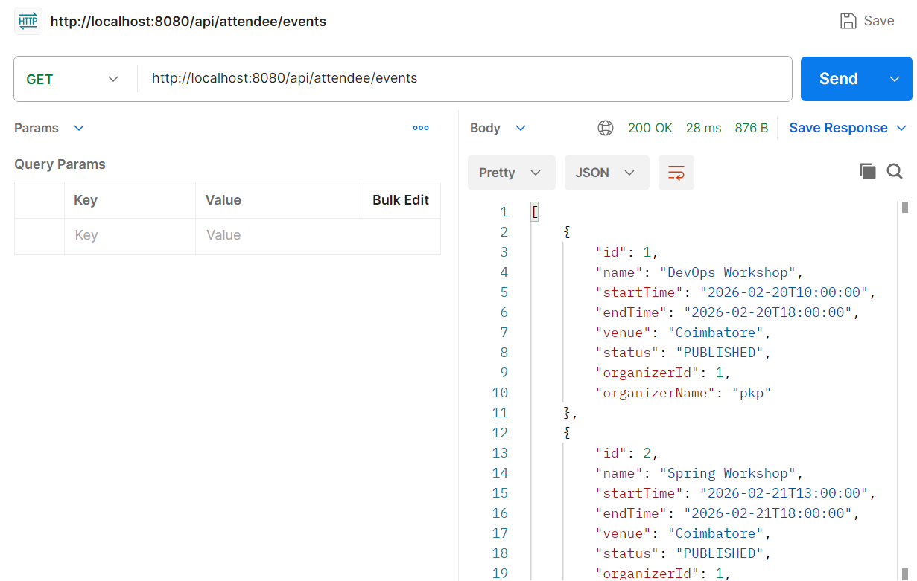

2.8 Get Event for particular ID - (ROLE_ATTENDEE)
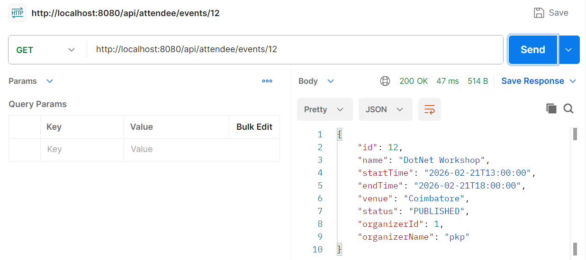

- TicketTypes
3.1 Create TicketType - (ROLE_ORAGANIZER)
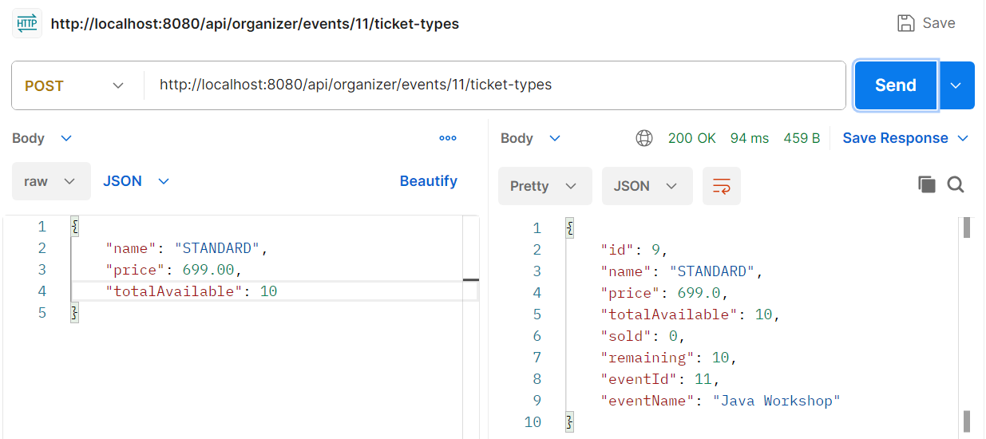

3.2 List All TicketTypes of a event- (ROLE_ORAGANIZER)
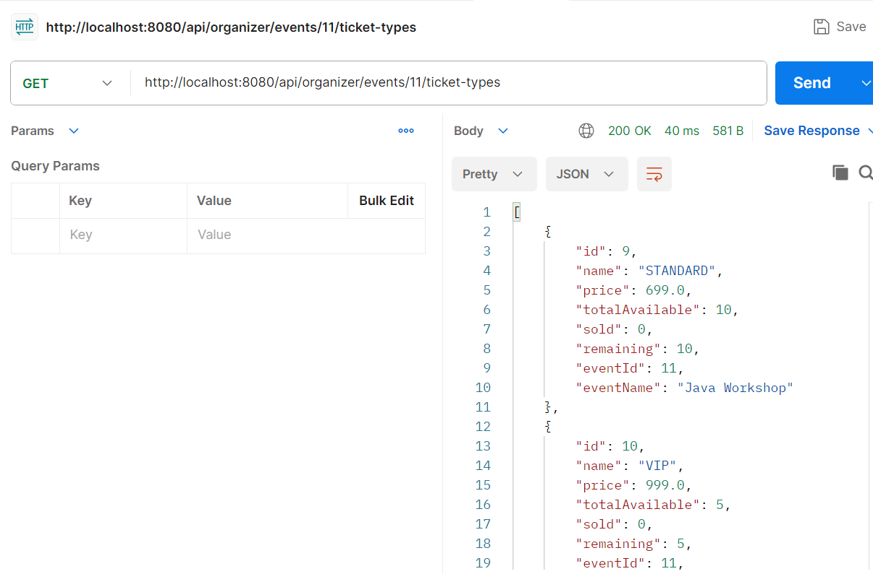

- Ticket
4.1 Purchase a TicketType of a event- (ROLE_ATTENDEE)
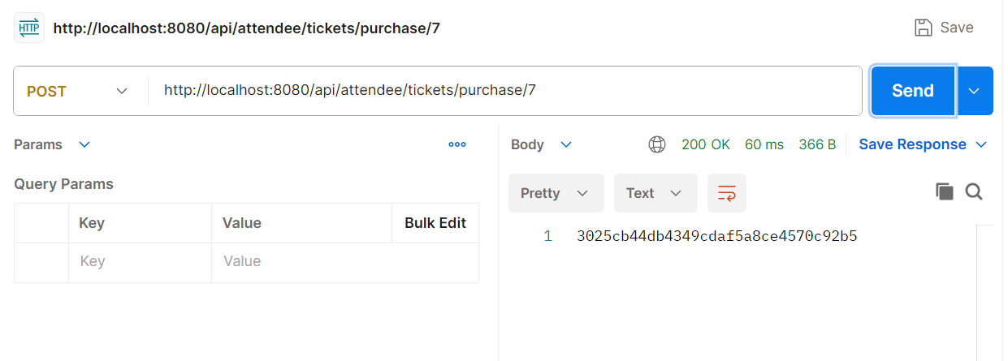

4.2 List All Tickets of an Attendee- (ROLE_ATTENDEE)
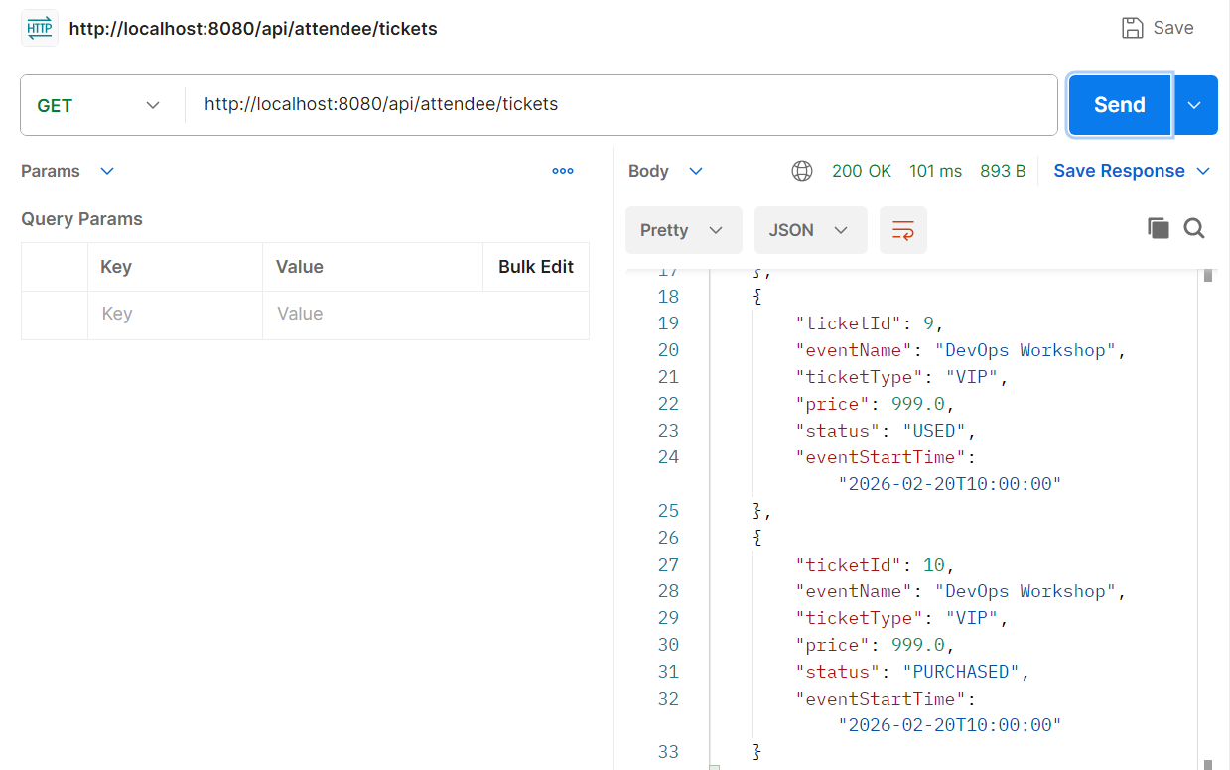

4.3) List All TicketQr of an Attendee
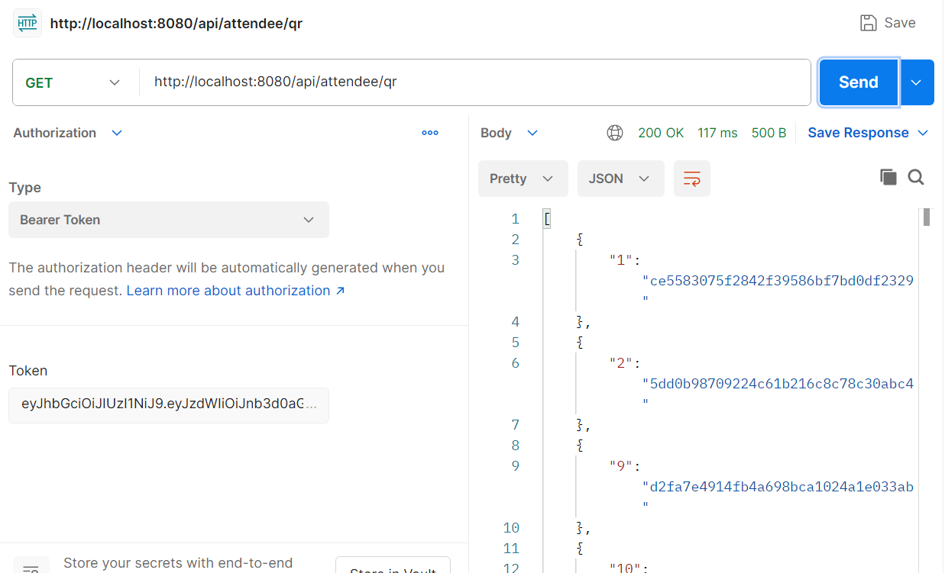

- Ticket Validation
5.1) Validate an attendee’s ticket for a event by an assigned staff
